|  |  |  |  |  |  |
| --- | --- | --- | --- | --- | --- |
| **Mean rank** | | | | | |
|  | 125hz | 250hz | 500hz | 750hz | 1000hz |
| 3ms | 3.2428 | 3.01428 | 2.6285 | 3.11428 | 3 |
| 18ms | 3.6571 | 3.2 | 2.8714 | 2.5428 | 2.7285 |
| 48ms | 3.8857 | 2.8142 | 3.04285 | 2.6 | 2.6571 |

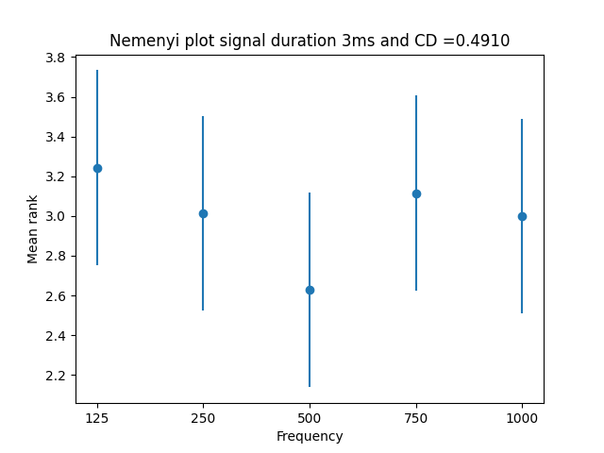

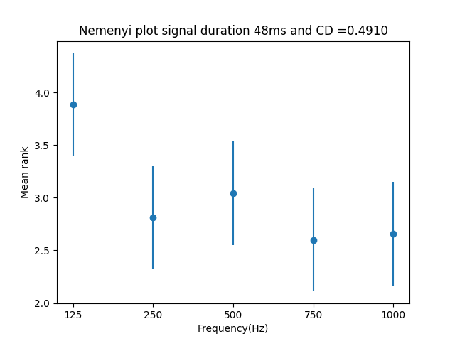

The interpretation of the Mean Rank Differences for BMLD using Nemenyi test involves identifying significant differences in BMLD between the frequncies based on their mean ranks and the critical difference value (CD = **0.4910** for 35 subjects and 5 frequenies). If the mean rank difference between two groups is greater than the CD value, the two groups are considered significantly different from each other.Cd is calculated as following

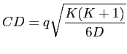

where K is the number of frequencies (5), D is the number of subjects (35) and the value of q is derived from the studentized range statistic.

To calculate the value of q for alpha=0.05 and K=5(number of frequencies), we need to refer to the Studentized range distribution table. The table provides critical values for the distribution at different levels of significance and degrees of freedom.

Degree of freedom (DF)= K(K-1)/2

For K=5, the degrees of freedom (df) would be equal to 10. Looking at the Studentized range distribution table, we can find the critical value q for DF=10 and alpha=0.05.

The value of q for alpha=0.05 and k=5 is approximately 2.905. the Resulting CD is **0.4910 and CD is the same for all durations because it depends on the number of frequencies and subjects**

**Initially, the results and CD were incorrect because the K and D were wrong. This was all happening because data was not organized correctly according to frequencies and subjects in the matrix which was being used for statistical testing that’s and was ending up with wrong ranks and CD.**